Instrumentation: Ultrasonic Range Finder

Andrew Gough – 201237950

djb12169@uni.strath.ac.uk

I declare that this report is entirely my own work.

Signature __________________________________________________

Abstract:

Large and complex circuits can be broken into various small component circuits. By following this technique of abstraction a working range finder was able to be constructed from many small components.

The ultrasonic range finder has a range from 0.8m to 3.8m with an uncertainty in these measurements of 0.26%.

Introduction:

This project was designed to produce an electronic instrument from a basic design. This gave me experience of the various techniques used in circuit board manufacture, soldering, trouble-shooting and calibration whilst also providing a method of learning how to read complex circuit diagrams.

The main principle behind the ultrasonic range finder is that by measuring the time taken for a pulse to travel and then return to the transmitter the distance (d) between the range finder and the object that the pulse bounced off of can be measured as the time (t) can be found via use of the circuitry of the range finder whilst the velocity of the wave (v) is a known value in air (340ms-1)

For the final rangefinder setup, there was however no component to directly convert the signal acquired into a distance. Instead a voltmeter was attached across the output which correlated with a direct proportionality to the distance from the range finder to the object. These voltages were recorded and then used to produce a table which maps voltage values to the resultant distance.

Theory:

The principle of operation is measurement of distance via the reflection of ultrasonic sound waves. The sound waves are produced and then transmitted from the 40 kHz transducer transmitter which then bounce off of the object and then are detected by the 40 kHz transducer receiver. The sound waves are bulk waves which more through the air and therefore have a velocity (v =340ms-1). The distances that the wave has travelled can be denoted via the use of the equation

Equation 1: $d=vt$

where v is the speed of sound in the material, t is the time that the wave travels for and d is the distance that the wave has travelled. The wave will travel through the air until it reaches the wall from which it will then reflect from and continue back through the air as an echo. This echo will then be picked up by the receiver on the circuit and then be converted back into voltage.

Design Outline:

A block schematic diagram of the instrument is shown in Figure 1.

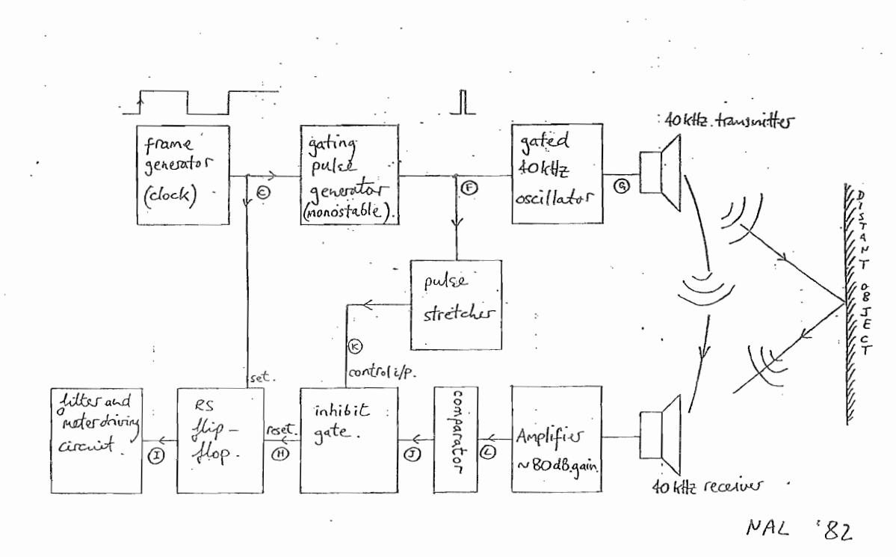

Figure 1 -Block Schematic Diagram of the Rangefinder

The range finder can be split into two distinct sections with several subsections. The top section of Figure 1 contains the transmitter section which can be broken down to:

The Frame Generator

The Gating Pulse Generator

The Pulse Stretcher

The Gated 40kHz Oscillator

Whereas the bottom section of Figure 1 contains the receiver section which can be broken down to:

The High-Gain Amplifier

The Noise Filter

The Comparator

The Inhibit gate

The RS Flip-Flop

The Frame generator:

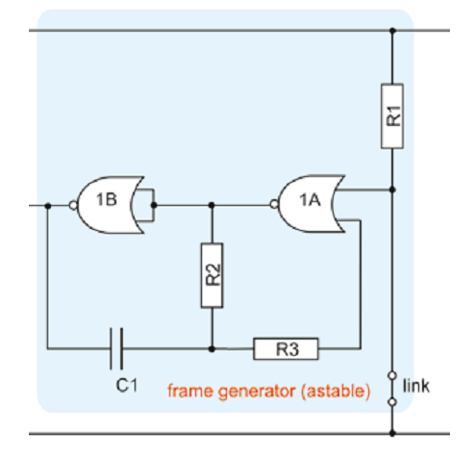The circuit below is employed in the rangefinder project as a frame generator which allows the production of a square wave output at Vg2 with a period of approximately 34ms(a frequency of 30Hz). This period can be adjusted by varying the values of components R and C. The NOR gate 1B in this context is wired as a not gate and therefore functions as a NOT gate and inverts the signal in the circuit so that a logical 0 at its inputs produces a logical 1 at its output. Therefore a square wave can also be produced from the output of 1A.

Figure 2 - Frame Generator Crcuit Diagram

The Gating Pulse Generator:

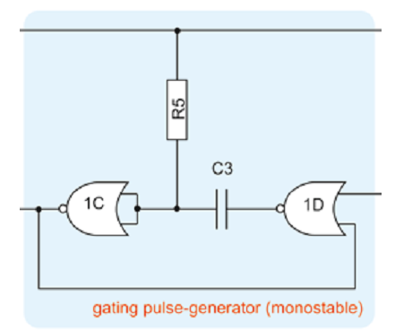

Figure 3 - Gating Pulse Generator (Monostable) Circuit Diagram

The Gating Pulse Generator or the CMOS monostable circuit is a useful circuit which effectively works as a pulse regulator as when triggered with a single positive logic 1 pulse at its input generates a single pulse of fixed width. This pulse is variable between 1 µs and several hundred seconds with varying the components R and C (R5 and C3) in this picture while the input trigger may be as little as a microsecond in duration.

The circuit is shown below, in its resting state, the output of the circuit is at logic 0 and this level is fed back to the input 1D. However as a logic 1 signal is directed towards the input 1D the capacitor will then fill with charge and begin the timing circuit which then retains a signal for the specified time period.

The Pulse Stretcher:

The pulse stretcher serves to lengthen the pulse, this can be shown in the waveforms for E where there is a pulse for a short length of time whereas after the pulse stretcher the pulse is much longer. The pulse stretcher functions in the same way as the gating pulse generator.

The Gated 40 kHz Oscillator:

The Gated 40kHz Oscillator sends out pulsed signals to the transmitter, this is achieved by the oscillator turning off at a regular interval producing a square wave of frequency 40 kHz. This frequency can be adjusted by changing the potentiometer within the Gated 40kHz Oscillator circuit. This frequency is the resonant frequency of both the transmitter and receiver transducers.

The High-Gain Amplifier:

The weak signals which are picked up by the receiver from the returning signals will need to be amplified in order to be “read” by the comparator section. The amplifier circuit contains an op amp which serves to increase the voltage of the read signal which then gets passed on to the comparator section through AC coupling.

The Noise Filter:

The Noise filter is called the Sallen and Key 2-pole low-pass filter. This noise filter includes two paralleled capacitors which provide feedback (unity gain) this feedback is then applied to the mid-point of the two resistors which allows the filter to be turned into an active filter – allowing for improved performance. The cut-off frequency of the filter is determined by the RC time constant for the circuit.

The Comparator:

The Comparator circuit is composed of NOR gates and works by outputting a logic 1 signal when the inputs to the circuit are above the threshold voltages. The threshold voltages were dictated by half of the supply voltage which therefore allowed the comparator circuit to output a logic 1 signal when supplied with a 4.5V or higher input signal.

The Inhibit Gate:

To stop the original signal from resetting the R-S flip flop the original signal needs to be “inhibited” to prevent the original signal from disrupting the timing circuit. The transmitter pulse which has been lengthened by the pulse stretcher shuts down the inhibit gate as the receiver transducers resonance produces an output even after the input has gone to 0. Due to this, the gating pulse is passed through a pulse stretcher to increase the inhibit time frame for a large enough time to avoid any interference from the original signal.

The R-S output:

The R-S latch functions as a rudimentary memory unit. When activated by a logic 1 signal from one input the latch will retain the signal until it is reset by another input signal. The start of the tone burst is signified by the R-S output that is controlled by the output from the frame generator. Once a signal has passed through the comparator – indicated a signal has been received – the R-S latch is then reset to provide a timer for the travel time of the transmitter wave pulse.

Method:

In order to ease construction of the ultrasonic rangefinder the overall circuit was built in 7 separated steps whilst waveform testing was performed after each section. This allowed to know that there was no faulty components and that the individual circuits were connected correctly.

1. First of all the gated oscillator was built – the base for the gated oscillator is the ubiquitous 555 timer (shown as IC3). The transmitter was connected between the output pin of the 555 timer and ground. C5, R7, R8 and RV1 were then soldered and RV1 adjusted so that the frequency of the tone was 40 kHz – this was required as the transmitter transducer is resonant in accordance to frequencies which varies from device to device.

This section was then tested via the positive side of the transmitter and ground to ensure that a 40 kHz pulse was being transmitted.

1. In the second section, the gating pulse generator was constructed. This consisted of two NOR gates contained within IC1. These are connected together via C3 and R5 with feedback to pin 9 of IC1 to form a monostable circuit. When given a high logic signal at pin 8 the output 11 goes high for a time determined by C3*R5.

This section was then tested via the

1. In the third section, the frame generator was constructed via use of the remaining two NOR gates from IC1. These are connected together to form a multivibrator circuit which produces a square wave at pin4 of frequency determined by (C1*R2)-1
2. The fourth section to be constructed was the amplifier section – this consists of two low noise transistors (T1, T2) in an emitter feed-back arrangement. The amplified signal is AC-coupled via use of C6 to the comparator circuit which consists of the NOR gate contained within IC2 and the resistors RA and RB. The comparator switches when the input voltage at pins 1 and 2 exceeds half of the supply voltage – 4.5volts when using a 9V battery. RA and RB have been selected to give a steady bias to pins 1 and 2 respectively. The signal from the receiver is then added to this level while any excursions which exceed the logic threshold will produce an output change at pin 3.
3. The fifth section to be completed was the timing circuit. This timing circuit was constructed from two cross-coupled NOR gates (2C and 2D of IC2). The output at pin 11 is set by a signal at pin 8 from the frame generator and reset by a signal at pin 13 from the pulse echo.

1. The sixth section to be completed was the filter and meter drive circuit. This uses an operational amplifier type CA3130 (IC4) operating as a voltage follower. R18 and C10 are also presented to R18 is a constant 6.8V irrespective of the battery condition to maintain the calibration. The op-amp output is then passed through the meter via R19 and RV2. RV2 was then adjusted to provide calibration.
2. The remainder of the circuit was then completed. The inhibit gate is the NOR gate located at 2a on IC2. Signal from the comparator will be passed and inverted only if the logic level at pin is low. While pin 5 is high, the output at 4 will be low irrespective of the signal on pin 6. The inhibit signal is generated from the oscillator gating pulse (pin 11 of IC1) stretched by means of RS and C4. The diode D1 by-passes RS at the beginning of the inhibit period, causing the low frequency noise to be filtered out. The diode becomes reverse-biassed once the gating pulse goes low again causing the inhibit pulse to have an exponential decay to the trailing edge. RS was then varied to calibrate the circuit due to variations in the component values.

Results:

The waveforms from the rangefinder were tested and recorded at regular intervals:

The gated oscillator was constructed on the board. After construction the voltage and frequency was measured via use of an oscilloscope:

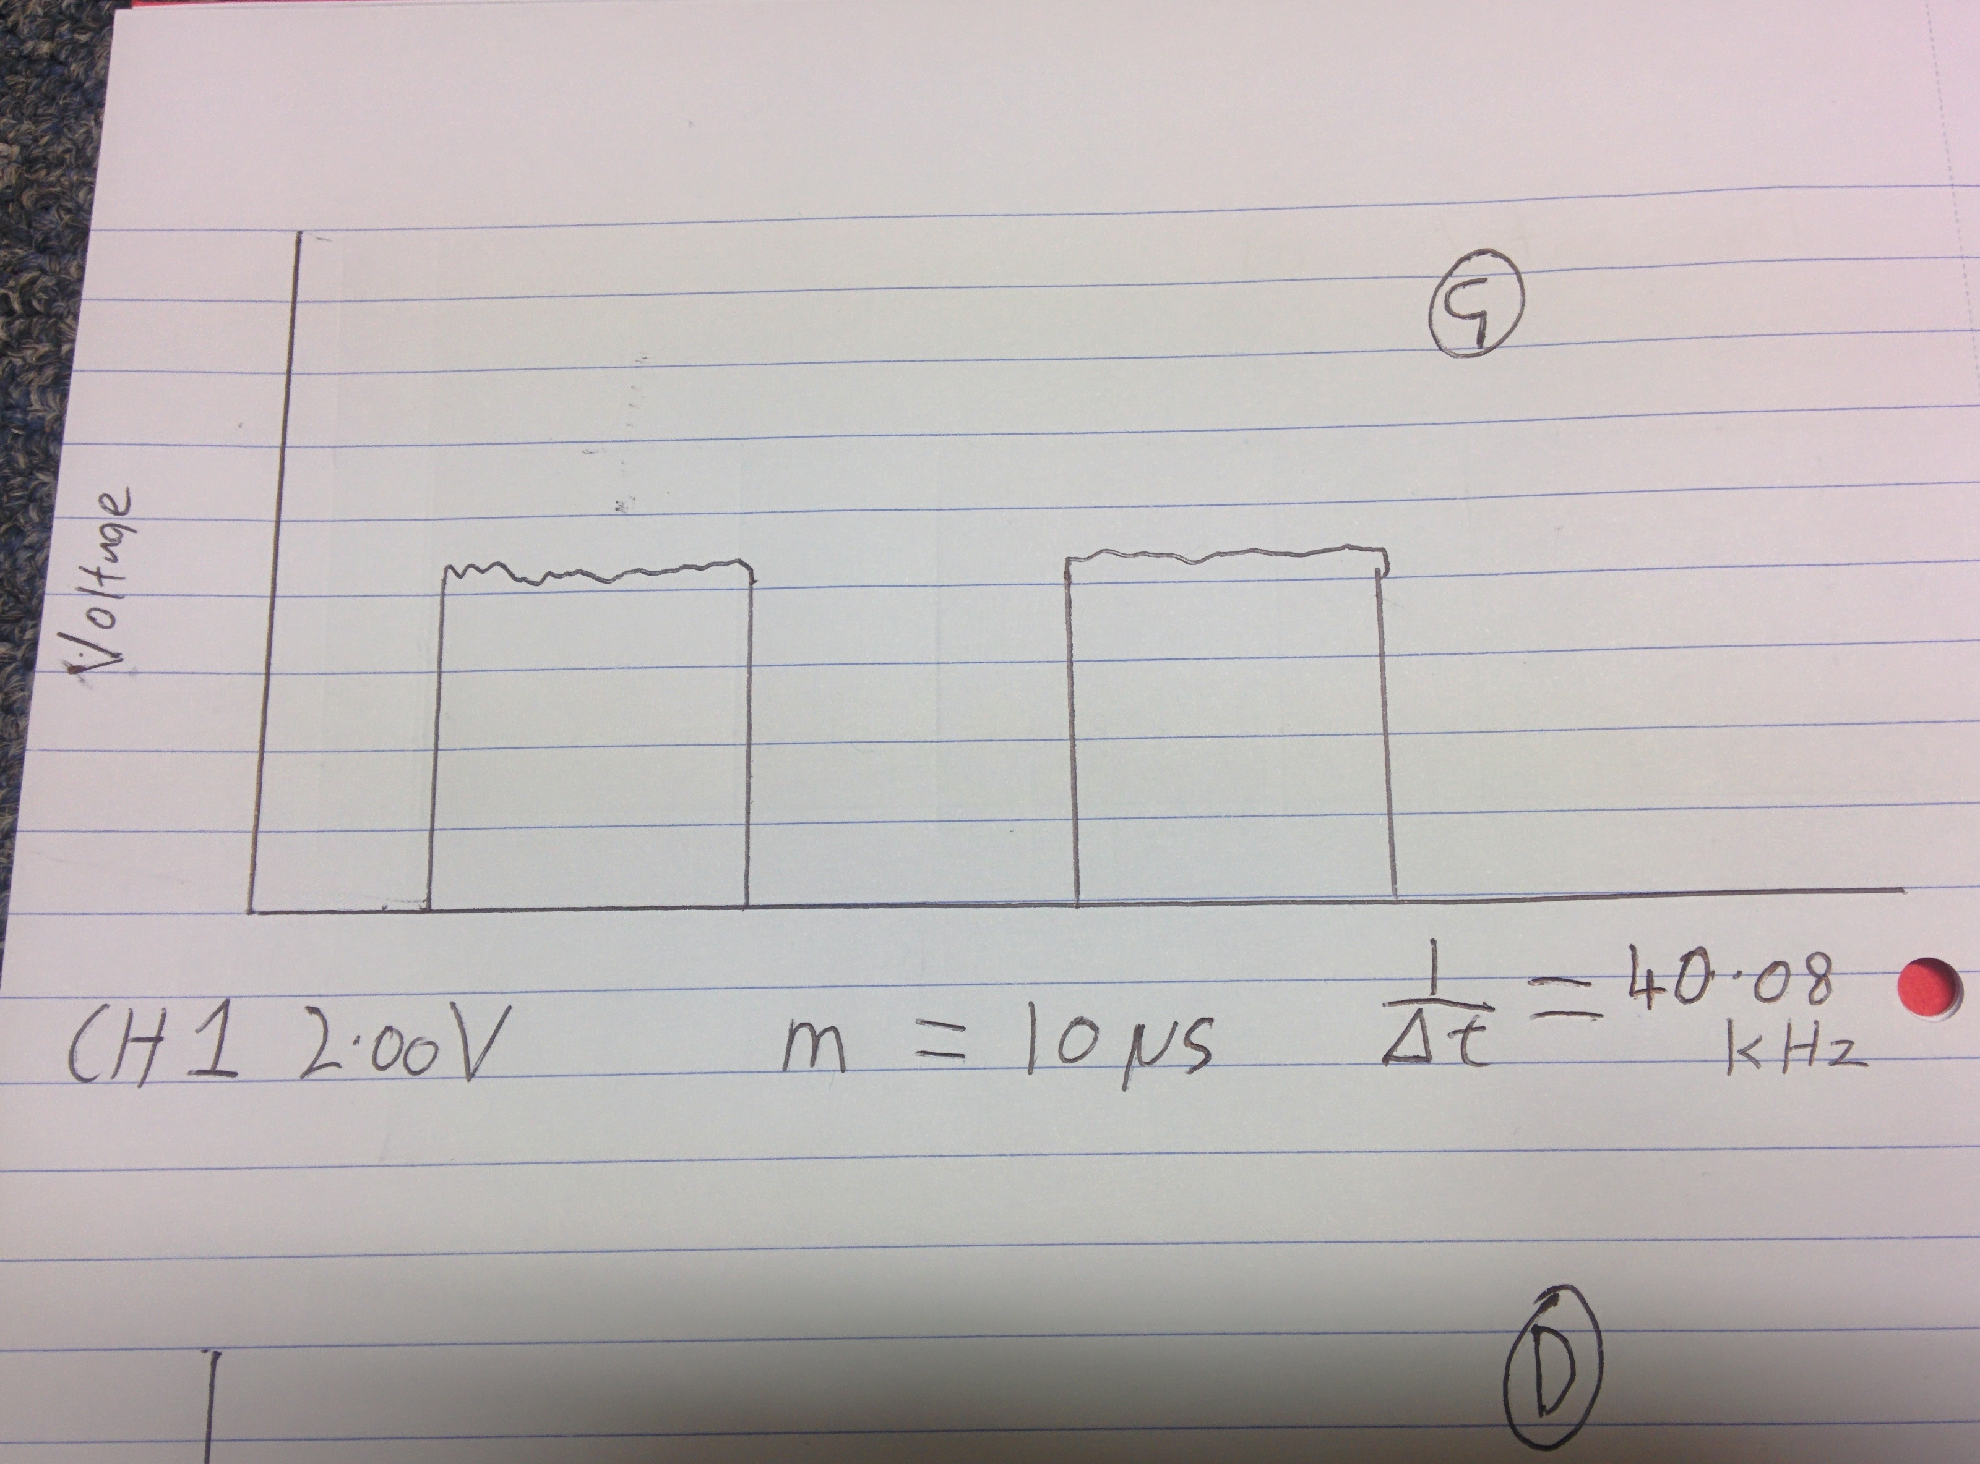

Figure 4 - Waveform found at G

The gated pulse generator was then added to the board.

From the top of the capacitor C3:

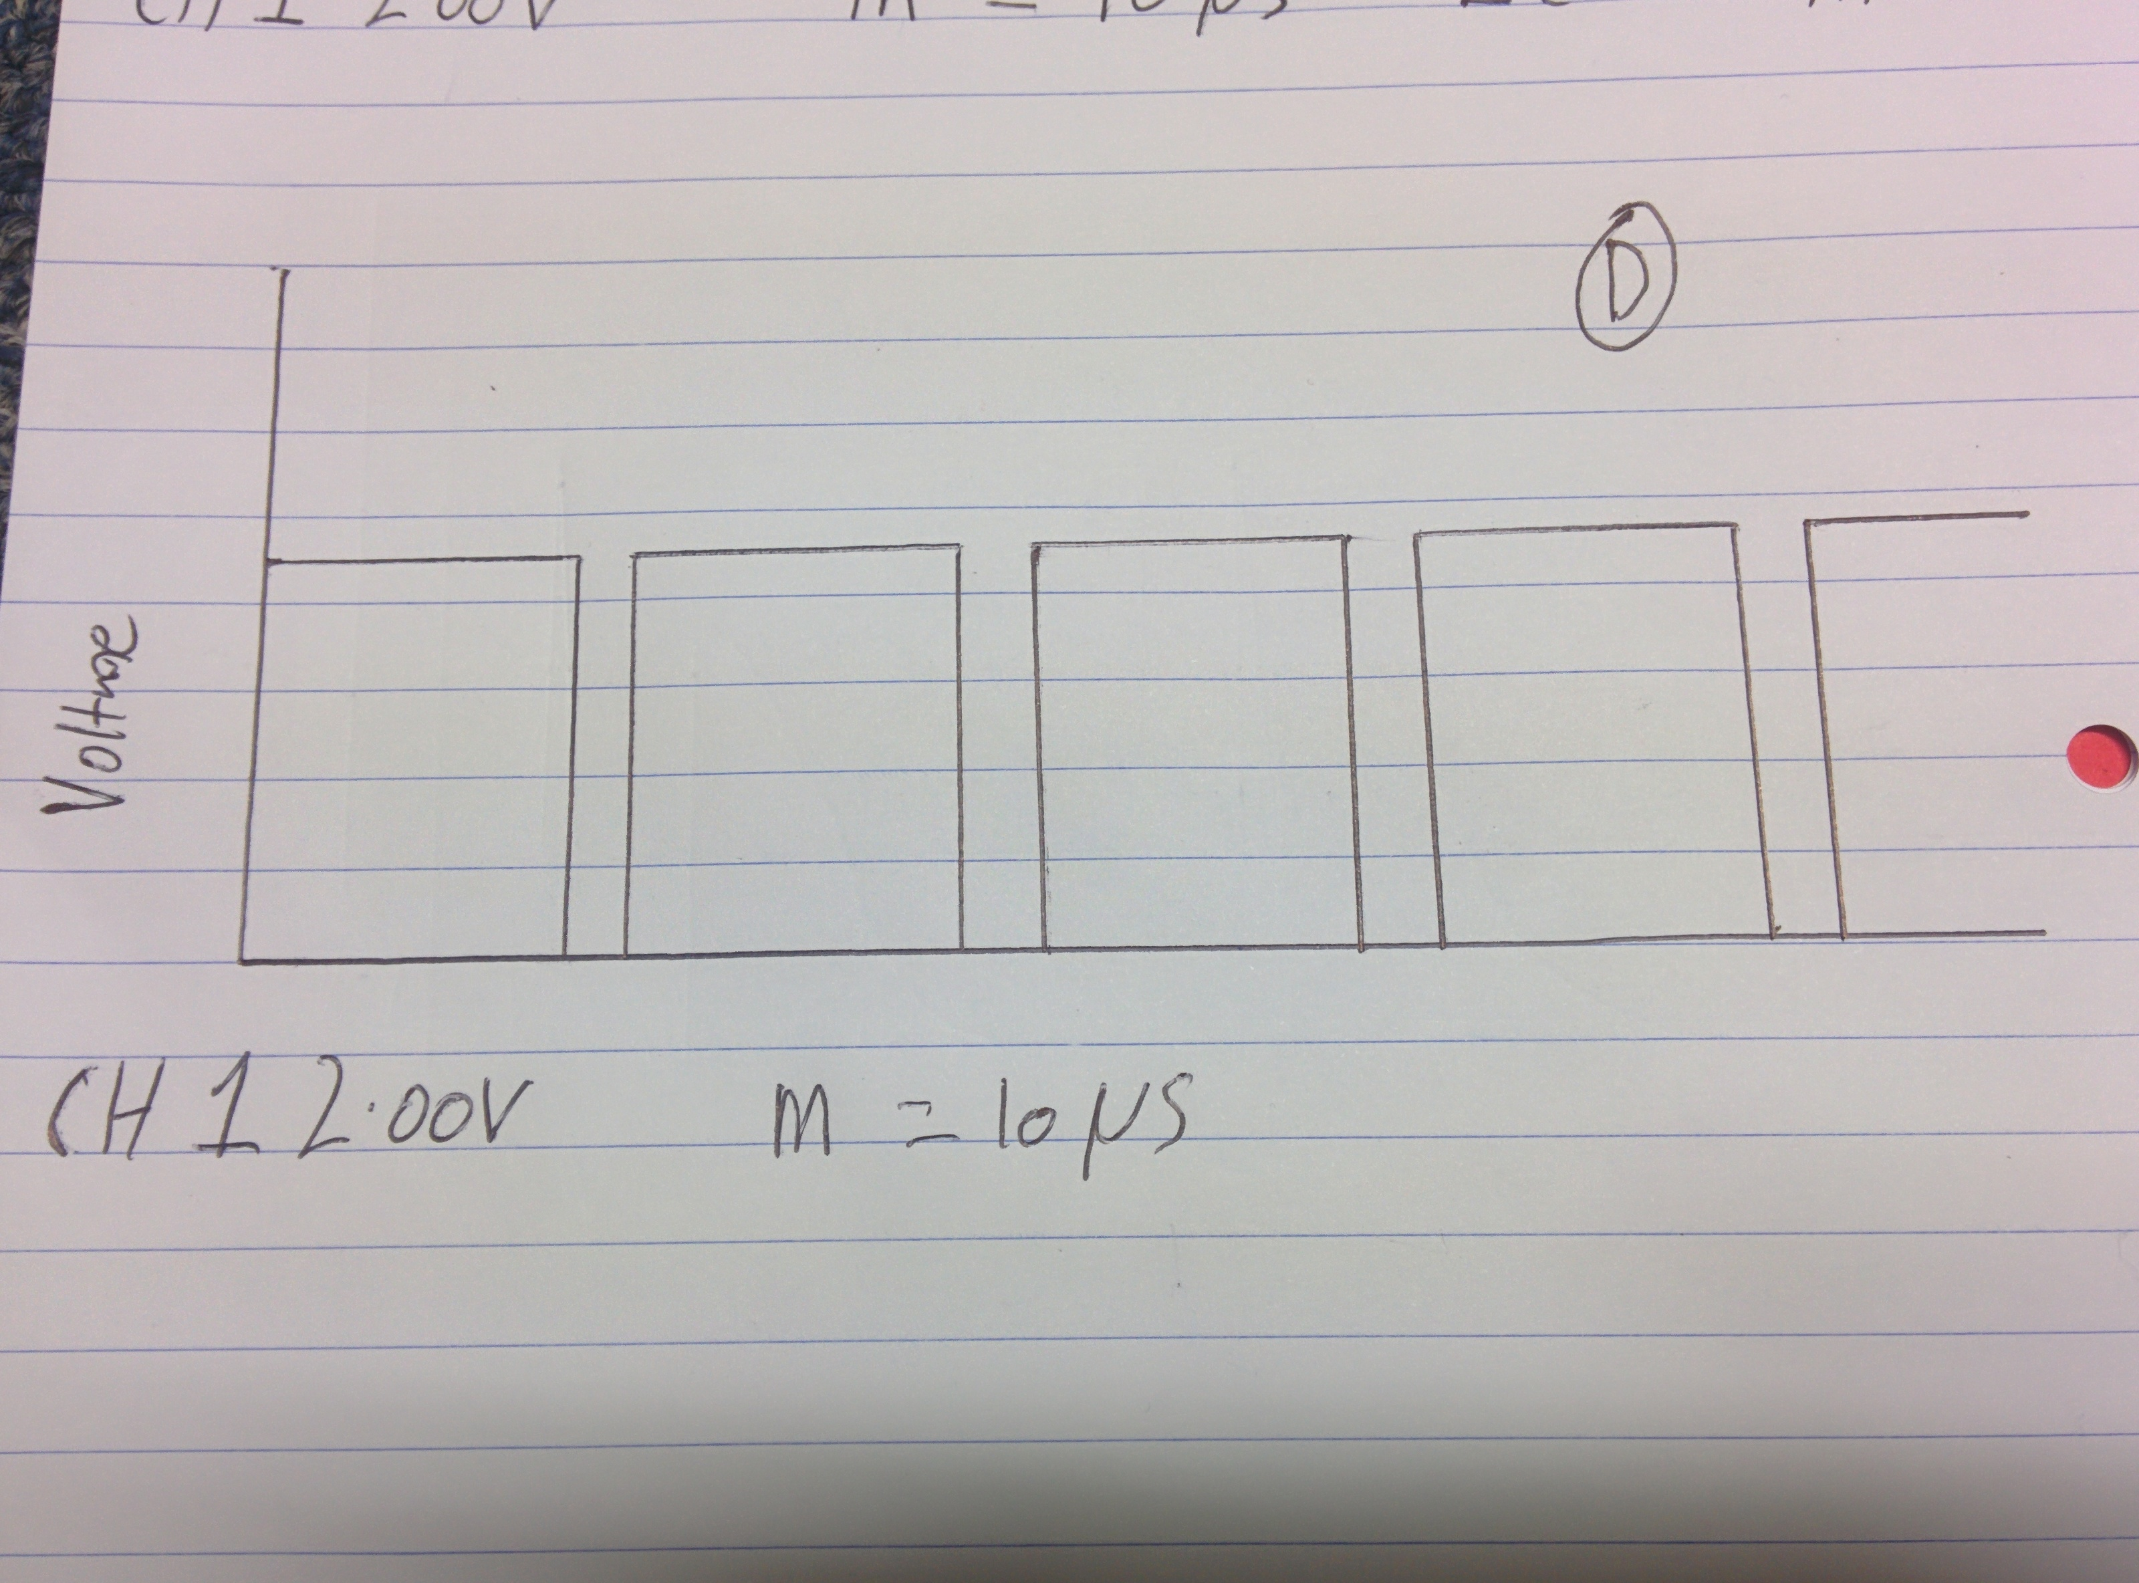

Figure 5 - Waveform found at Position D

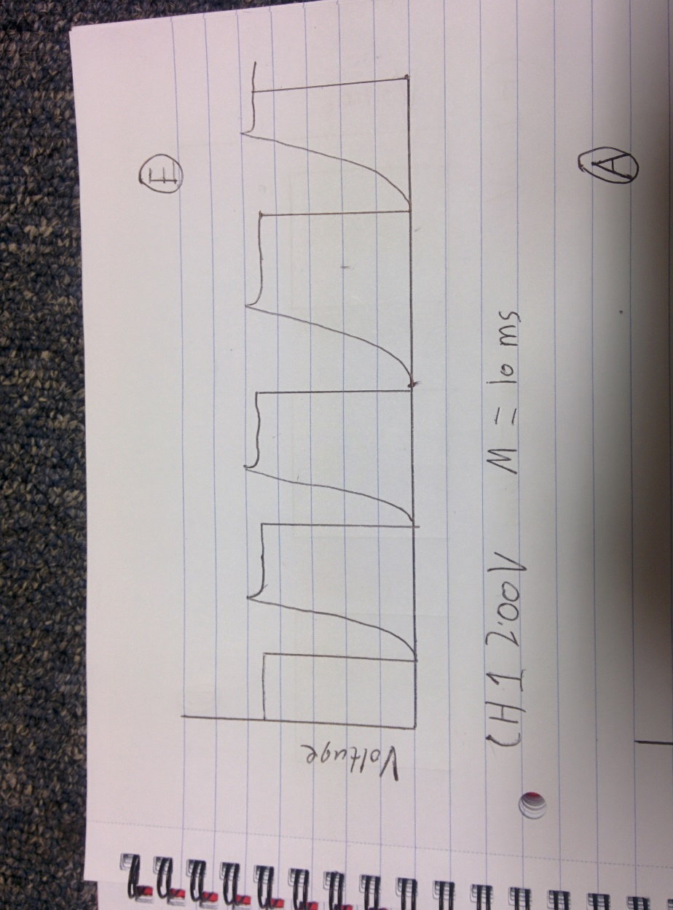From the bottom of capacitor C3

Figure 6 - Waveform found at position E

The frame generator was ten constructed to the right of the gating pulse generator.

When connected to R3

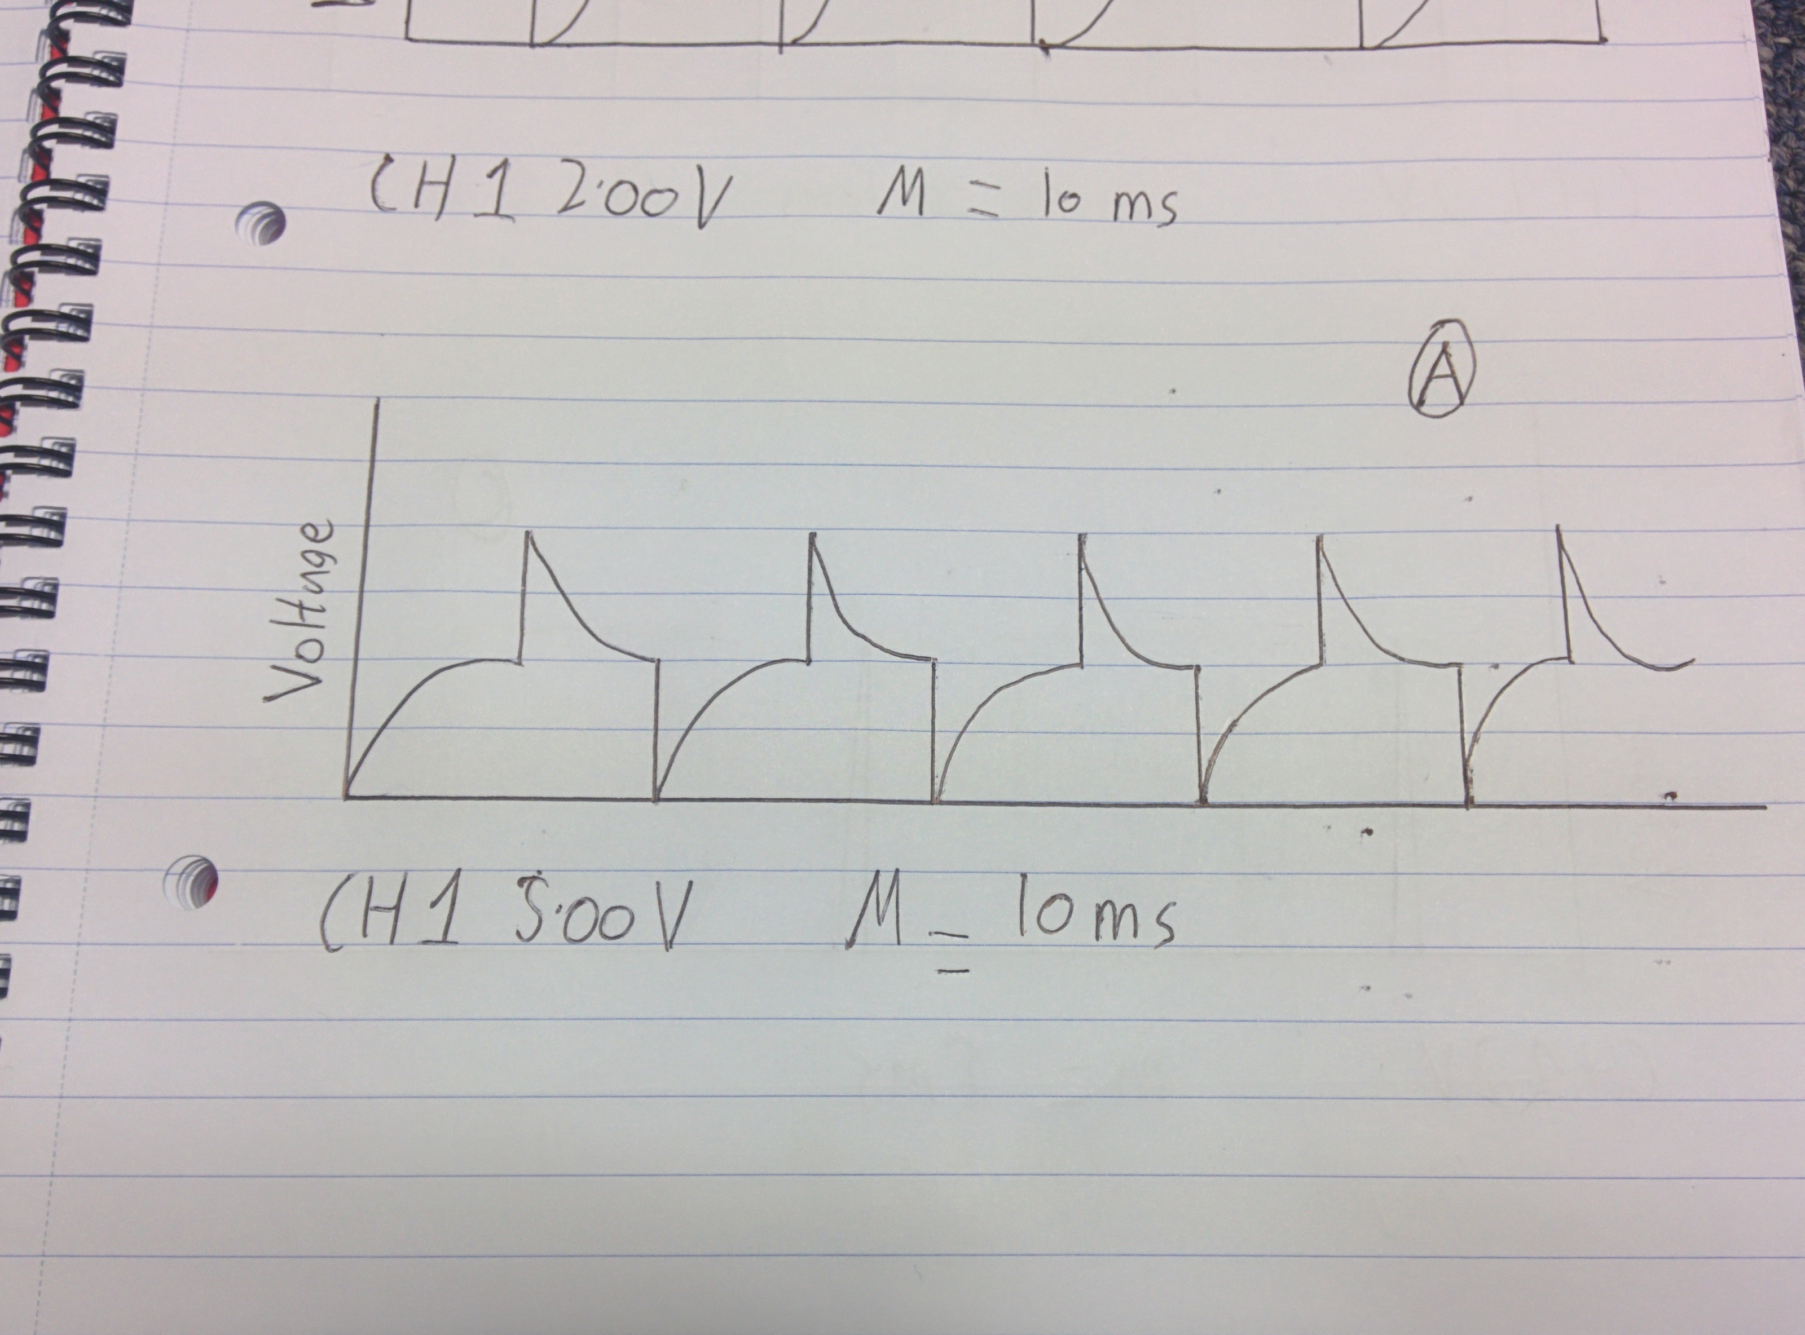

Figure 7- Waveform found at A

When connected to the right of C2

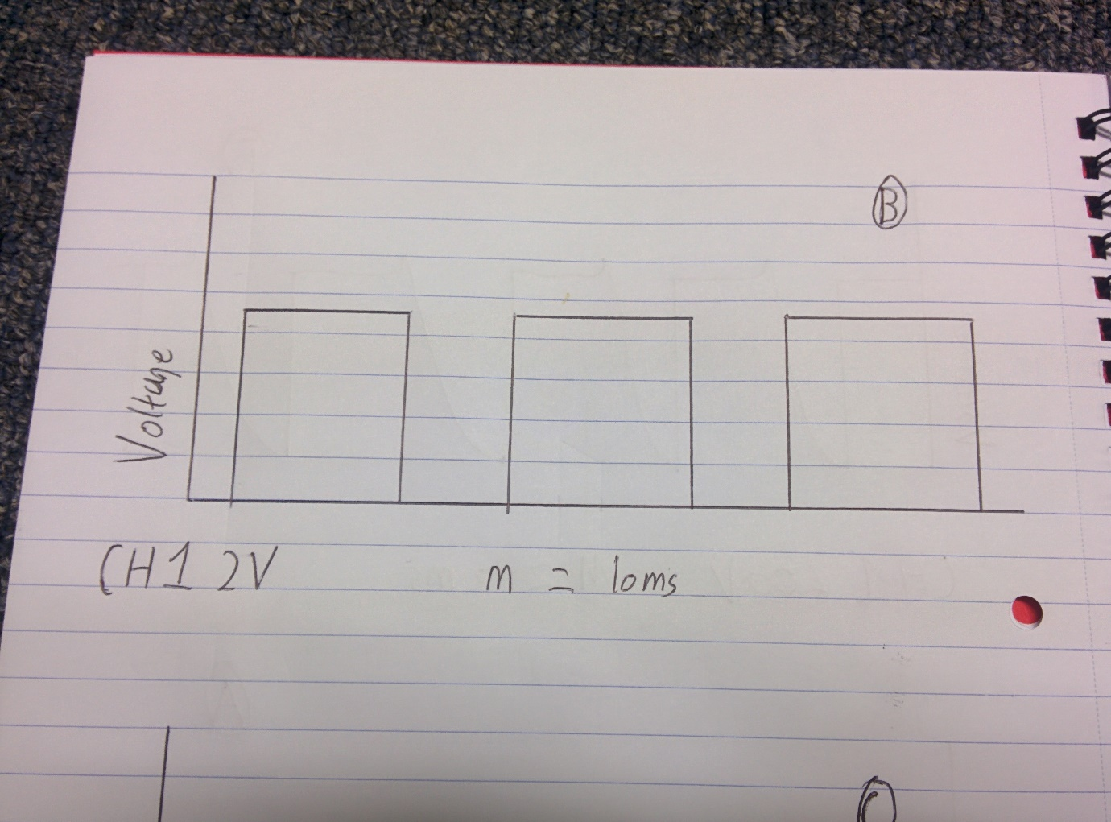

Figure 8 - Waveform at position B

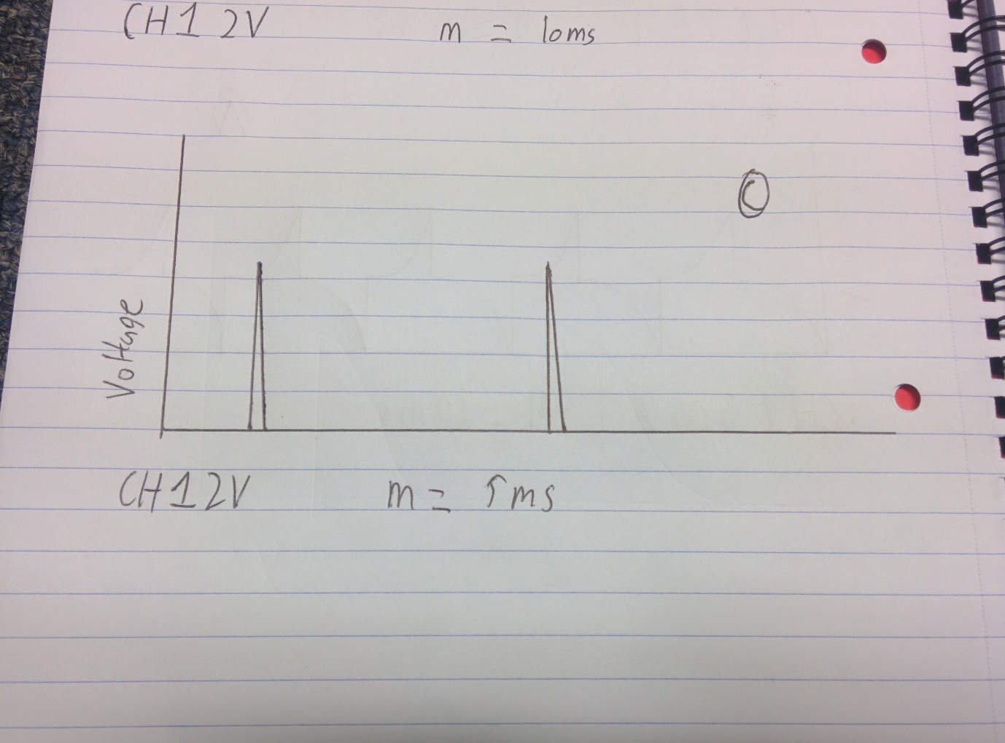When connected to the left of C2

The amplifier circuit was next to be added along with the receiver

Figure 9 - Waveform found at position C

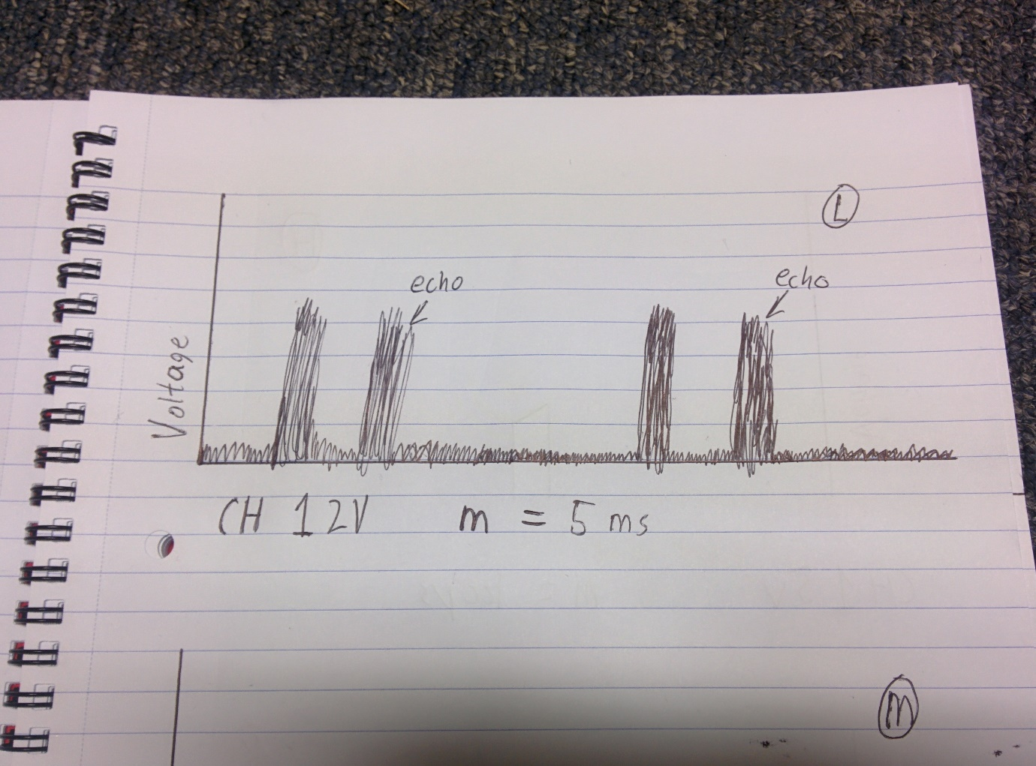

Figure 10 - Waveform found at position L

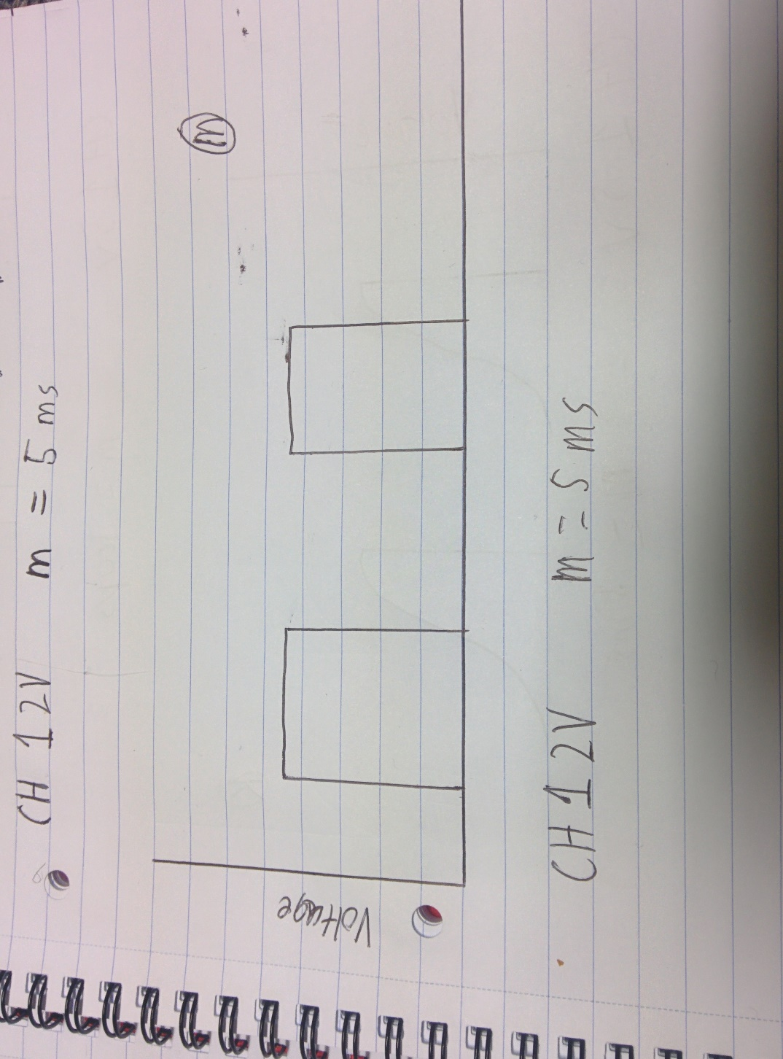The spacing between pulse and echo increases linearly with distance to the ceiling.

The R/S flip flop was then added into the circuit along with the filter and meter drive.

Figure 11- Waveform found at position M

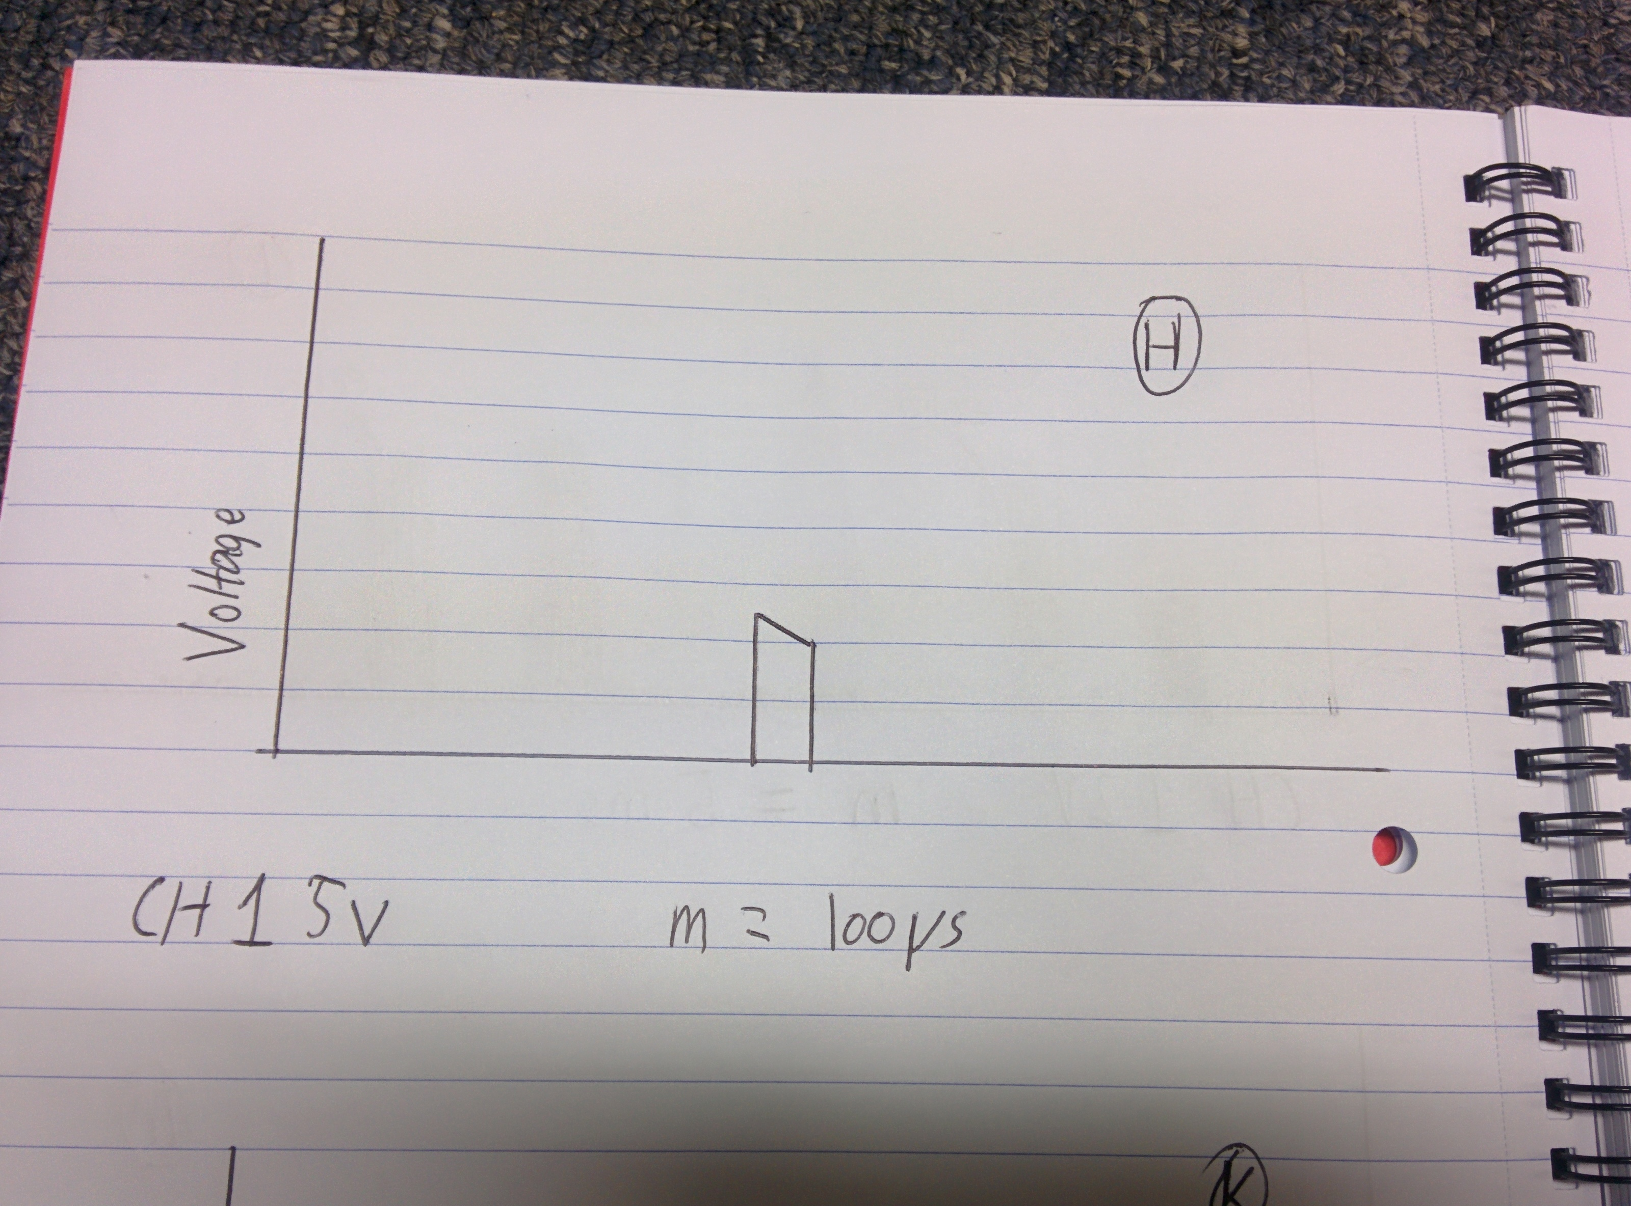

Figure 12- Waveform found at position H

The inhibit gate and remaining components were then added – excluding C14 and C13

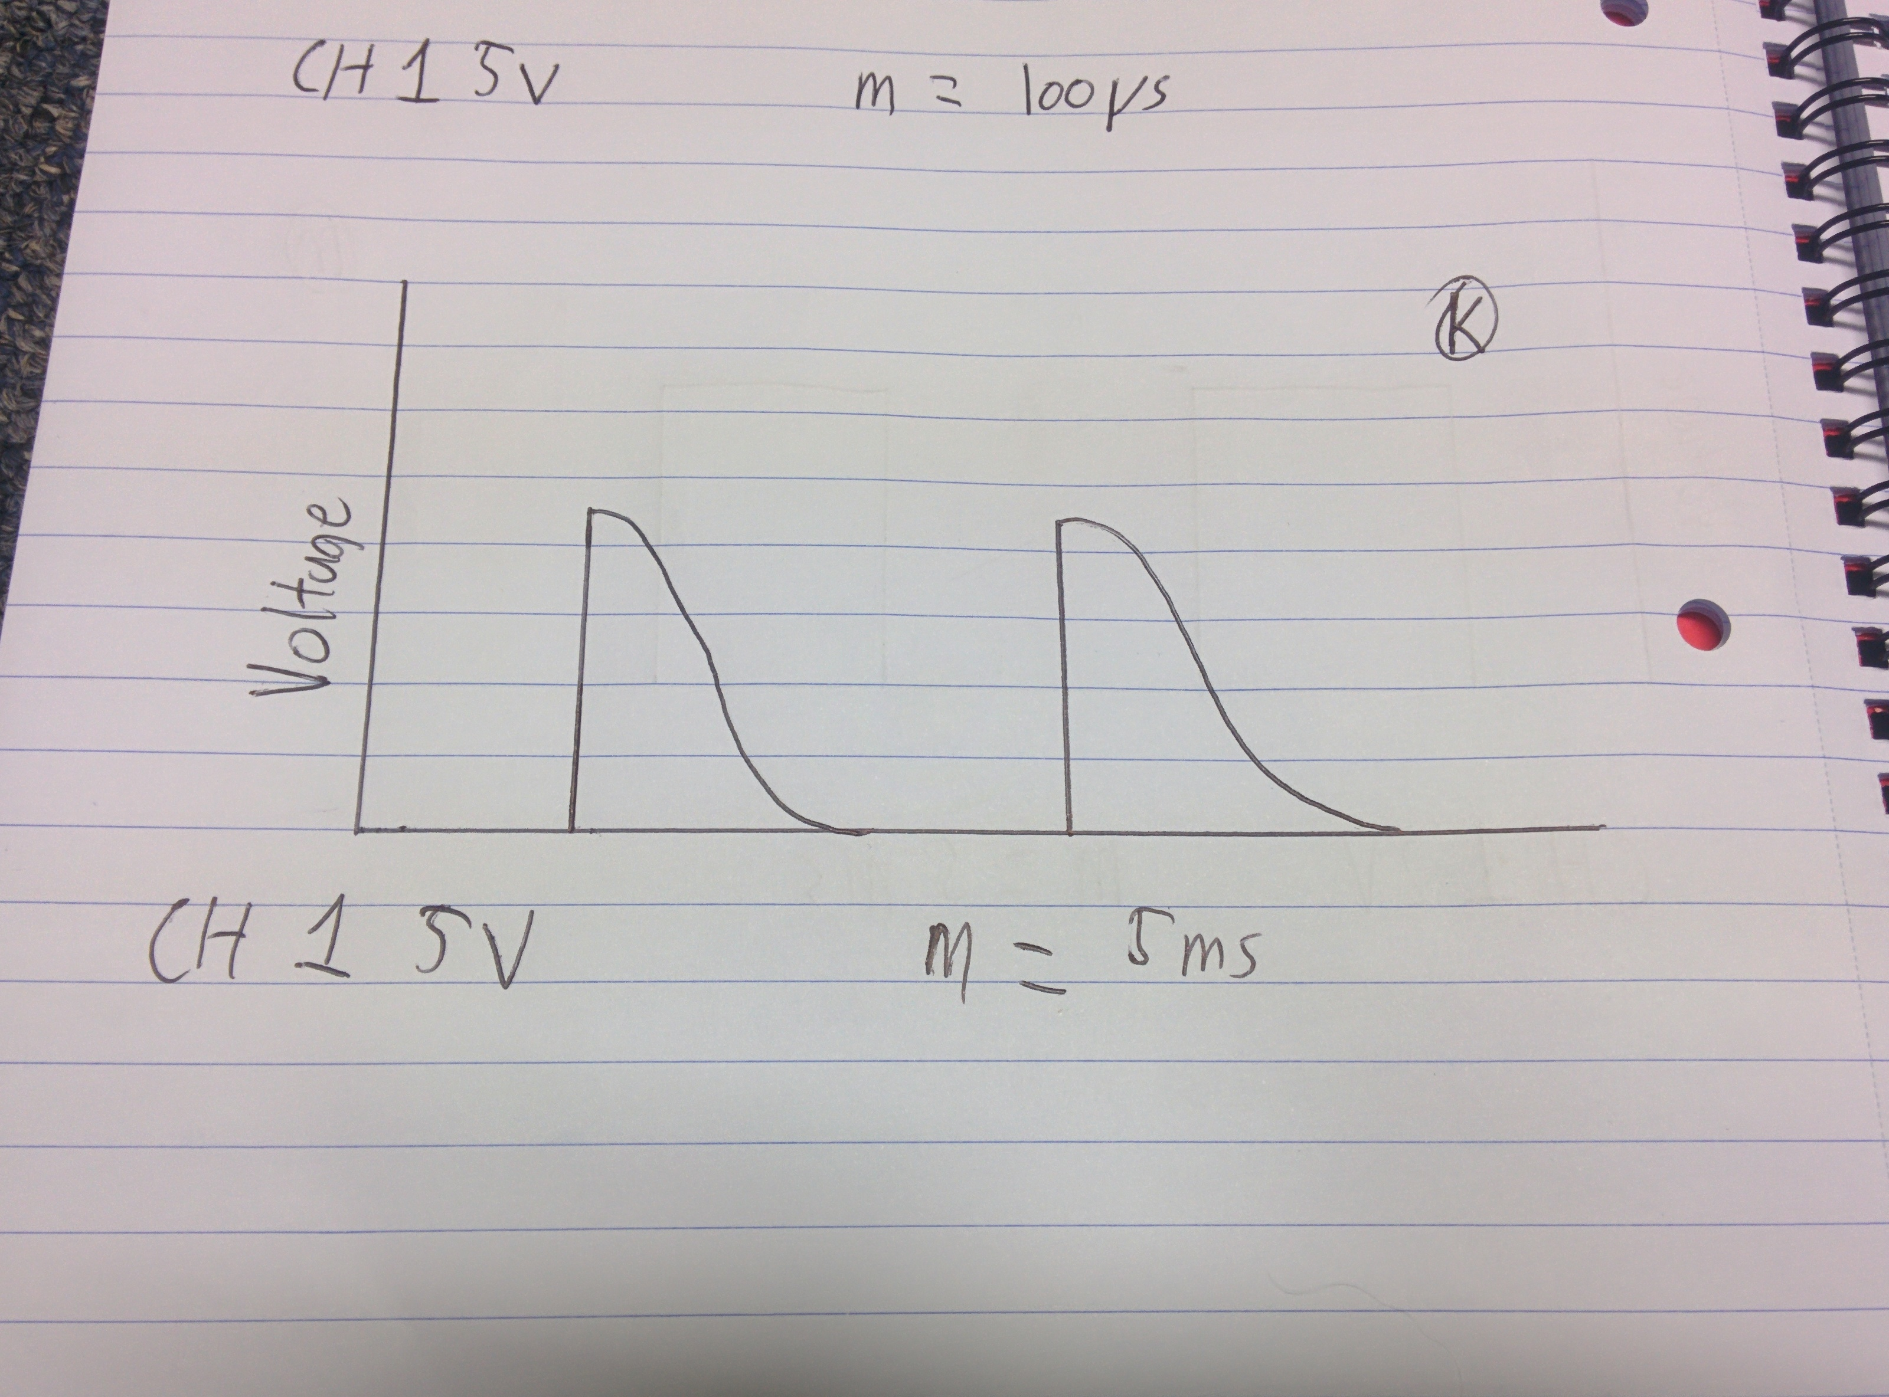

Figure 13- Waveform found at position K

To boost the strength of the signal RA and RB were removed.

The saw tooth wave was then found

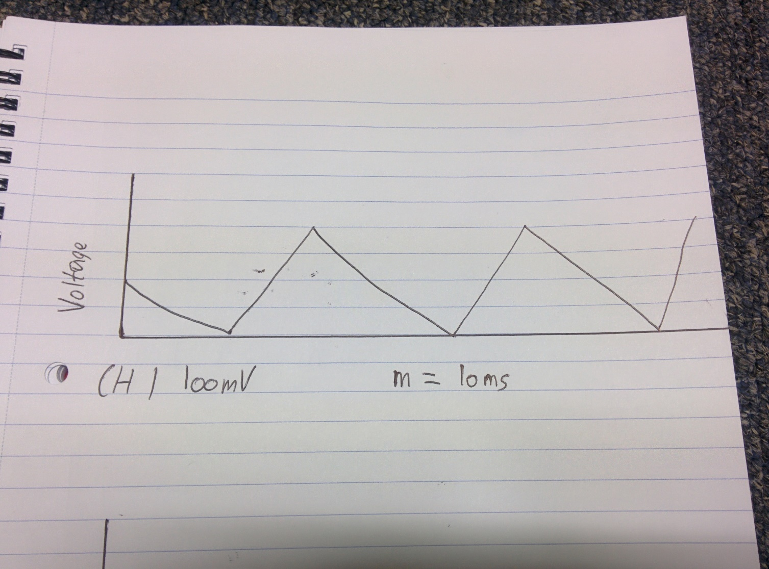

Figure 14 - Sawtooth wave found at output

From measuring the peak to peak amplitude is found to be 240Mv whilst the time between peaks is 34ms.

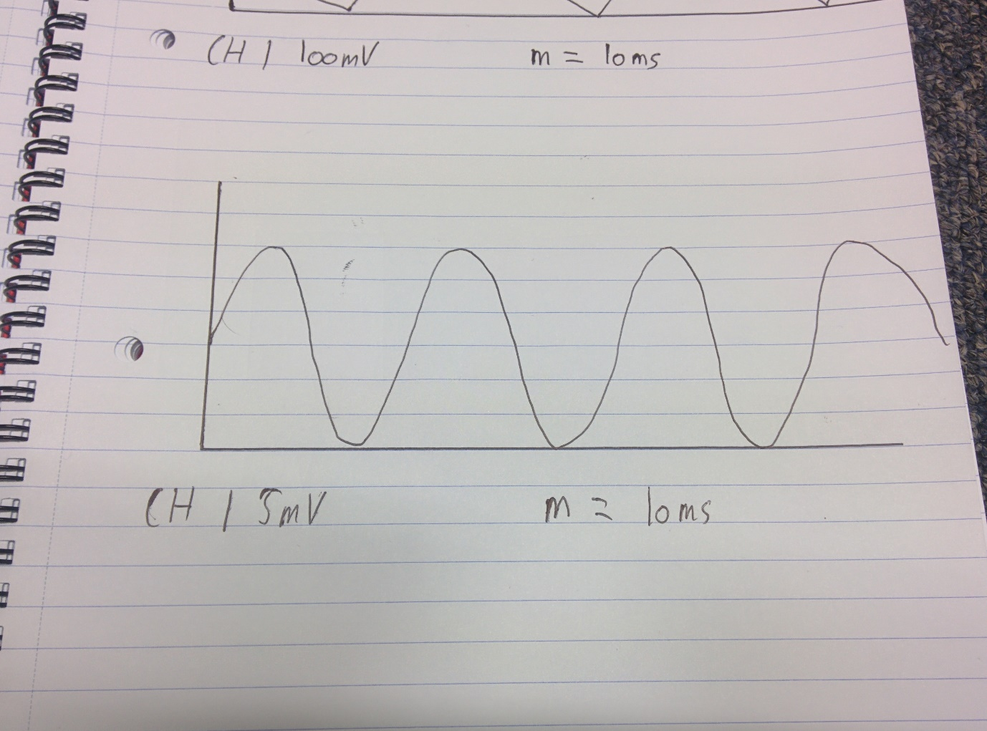When C13 and C14 are added this waveform is smoothed.

Figure 15- Smoothed wave after C13 and C14 are added

The closest range that the range finder works at is 0.8m while the largest range the range finder works at is 3.8m. These ranges have an uncertainty of 0.026% associated with them.

|  |  |  |  |
| --- | --- | --- | --- |
| Distance | Recorded Voltage | Theoretical Voltage | Residual (%) |
| 0 | 6.4 | 0.006711902 | 99.8951265 |
| 0.1 | 1.01 | 0.120553949 | 13.8975945 |
| 0.2 | 1.02 | 0.234395996 | 12.2750626 |
| 0.3 | 1.02 | 0.348238042 | 10.4962806 |
| 0.4 | 1.02 | 0.462080089 | 8.71749861 |
| 0.5 | 1.02 | 0.575922136 | 6.93871663 |
| 0.6 | 1.01 | 0.689764182 | 5.00368465 |
| 0.7 | 1.02 | 0.803606229 | 3.38115267 |
| 0.8 | 1.02 | 0.917448276 | 1.60237069 |
| 0.9 | 1.04 | 1.031290323 | 0.13608871 |
| 1 | 1.16 | 1.145132369 | 0.23230673 |
| 1.1 | 1.27 | 1.258974416 | 0.17227475 |
| 1.2 | 1.38 | 1.372816463 | 0.11224277 |
| 1.3 | 1.49 | 1.486658509 | 0.05221079 |
| 1.4 | 1.6 | 1.600500556 | -0.0078212 |
| 1.5 | 1.71 | 1.714342603 | -0.0678532 |
| 1.6 | 1.83 | 1.82818465 | 0.02836485 |
| 1.7 | 1.94 | 1.942026696 | -0.0316671 |
| 1.8 | 2.05 | 2.055868743 | -0.0916991 |
| 1.9 | 2.15 | 2.16971079 | -0.3079811 |
| 2 | 2.3 | 2.283552836 | 0.25698693 |
| 2.1 | 2.41 | 2.397394883 | 0.19695495 |
| 2.2 | 2.5 | 2.51123693 | -0.175577 |
| 2.3 | 2.63 | 2.625078977 | 0.07689099 |
| 2.4 | 2.77 | 2.738921023 | 0.48560901 |
| 2.5 | 2.83 | 2.85276307 | -0.355673 |
| 2.6 | 2.93 | 2.966605117 | -0.5719549 |
| 2.7 | 3.09 | 3.080447164 | 0.14926307 |
| 2.8 | 3.17 | 3.19428921 | -0.3795189 |
| 2.9 | 3.26 | 3.308131257 | -0.7520509 |
| 3 | 3.43 | 3.421973304 | 0.12541713 |
| 3.1 | 3.52 | 3.53581535 | -0.2471148 |
| 3.2 | 3.63 | 3.649657397 | -0.3071468 |
| 3.3 | 3.74 | 3.763499444 | -0.3671788 |
| 3.4 | 3.86 | 3.877341491 | -0.2709608 |
| 3.5 | 4.03 | 3.991183537 | 0.60650723 |
| 3.6 | 4.14 | 4.105025584 | 0.54647525 |
| 3.7 | 4.22 | 4.218867631 | 0.01769327 |
| 3.8 | 4.38 | 4.332709677 | 0.73891129 |
| 3.9 | 6.4 | 4.446551724 | 30.5226293 |
| 4 | 6.4 | 4.560393771 | 28.7438473 |
| 4.1 | 6.4 | 4.674235818 | 26.9650654 |
| 4.2 | 6.4 | 4.788077864 | 25.1862834 |
| 4.3 | 6.4 | 4.901919911 | 23.4075014 |

Table 1: The above data shows the experimental data taken with the rangefinder.

By plotting the experimental data against the distance the following plot was found.

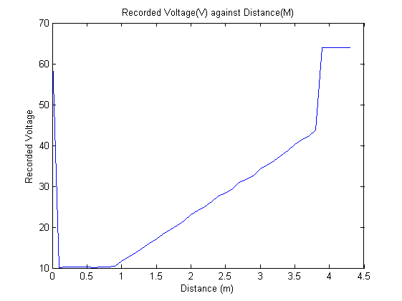

Figure 16 - The recorded voltage against the distance

This plot was then truncated to that of the working range, starting from 0.8m and ending at 3.8m

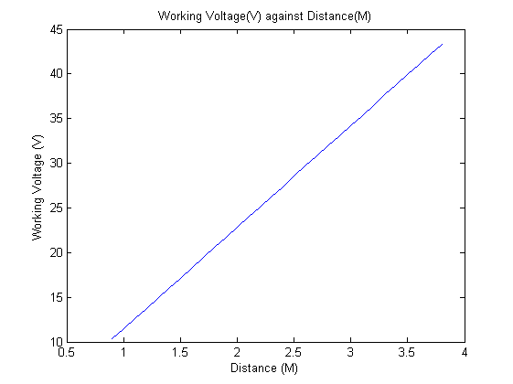

Figure 17- The working voltage against distance

By working out the gradient of the graph and therefore the theoretical ideal voltages, found in table 1, were found by expanding from between 0.8m and 3.8m

The residuals were then calculated by taking the difference of the recorded voltage and the theoretical voltage.

These were then plotted against distance.

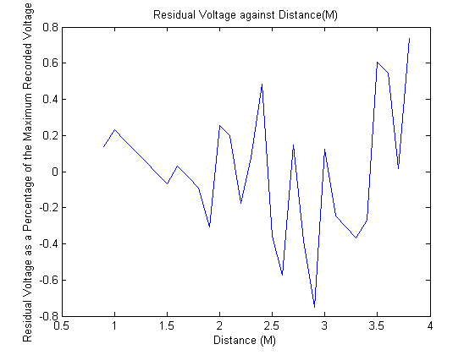

Figure 18 - residuals against distance

The uncertainty of the distances are found with the RMS value of the graph, this provided a value of 0.26% as an overall uncertainty in the value of the distance.

This led to an absolute uncertainty of ± 1cm.

Discussion

The range finder worked as expected due to the range being 3.8meters. The design specifications required a range of larger than 3meters. A potential flaw to the range finder was the length of time it took to read a single measurement of distance. The uncertainty of the range finder was 0.26% which is within a reasonable degree as it allows for an absolute uncertainty of ±1cm at 3.8m.

The performance of the range finder could be improved via increasing the amplitude at test point L as this allows for a larger distance to be measured. This does come with a trade off as while the amplitude increases at L so does the noise associated with the measurement.

Another way to improve the performance of the range finder is to ensure that all soldering is perfect and does not include any dry solders as this inhibits current flowing through the solder.

The final way to improve the performance of the range finder is to perform measurements in an isolated area far away from any other range finders as any stray signals could cause incorrect results.

Conclusions:

Large and complex circuits can be broken into various small component circuits. By following this technique of abstraction a working range finder was able to be constructed from many small components.

The ultrasonic range finder has a range from 0.8m to 3.8m with an uncertainty in these measurements of 0.26%.

Acknowledgement:

This report would not have been possible without the following:

Dr. N. Lockerbie – for providing the lab script and for providing a conduit of wisdom.

Dr. T. Han - for providing the lab script and for providing a conduit of wisdom.